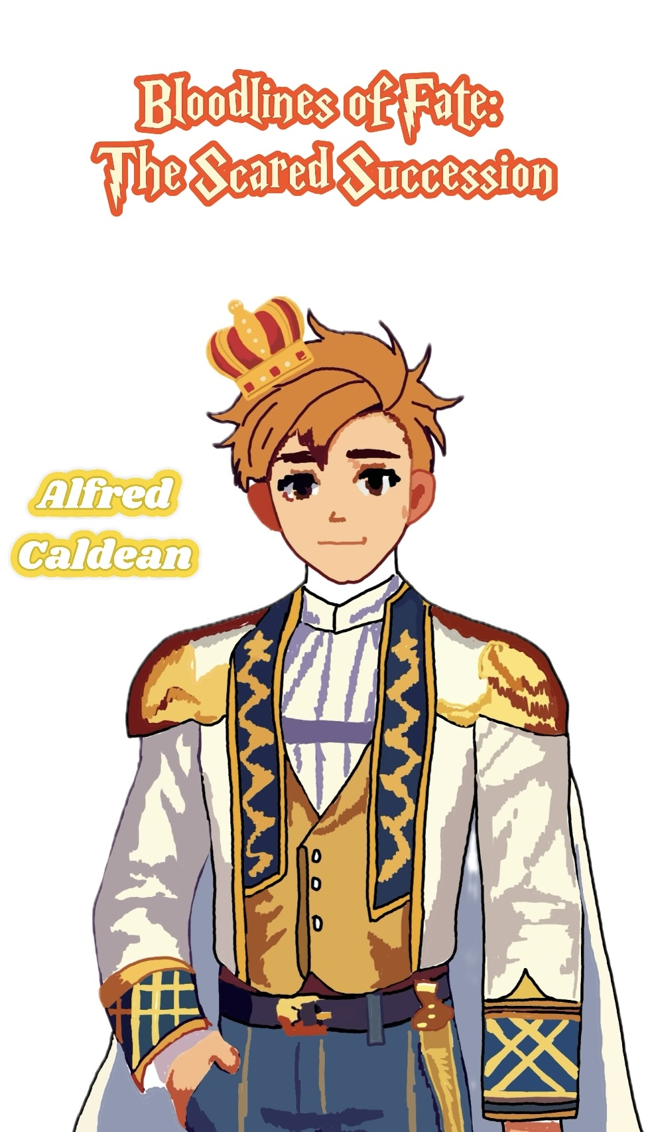

Alfred Caldean Player Handbook

1. Story Background and Current Situation
On a continent divided among the Caldean Kingdom, the Falor Theocracy, and the Nagari Tribe, the relationships between the nations have always been tense. The Caldean Kingdom is an absolute monarchy where noble blood is revered above all, and the royal family maintains power through the so-called "Blood of the King." The upcoming "Sacred Lion Succession Ceremony" is just ten days away, and you are about to inherit the throne and become the new king.
The Falor Theocracy was once part of Caldean but seceded centuries ago, establishing itself as a religious nation based on the doctrine of equality. However, the reality of equality within Falor is far from the ideal, with internal conflicts and extremist factions on the rise.
The Nagari Tribe is composed of slaves who revolted against the Caldean Kingdom twenty years ago. They fled the kingdom's oppression and now survive as nomads in the forests, constantly struggling against the Caldean forces for their freedom.

2. Player Character Information
Identity:
Alfred Caldean, the son of the current Caldean King, Edwin III, and seen as the kingdom's future and hope. You are set to inherit the throne and become the ruler of Caldean. As the sole heir to the royal family, you bear great responsibilities—strengthening royal authority, upholding the nobility's privileges, and suppressing internal and external rebellions. You are a symbol to the Caldean nobility and the military, and many see you as the guardian of the kingdom's future.
Background and Experiences:
You grew up in the royal palace, receiving a noble education from a young age—learning history, military strategy, politics, and the sacred tradition of the "Blood of the King." Since you were a child, your father repeatedly instilled in you the importance of this bloodline, telling you it was a divine gift, and only those with this power could lead the nation. You have always believed that royal blood is innately superior and that it is your duty to rule over others.
Your childhood was strict and lonely, with few opportunities to play with other children. Most of your time was spent studying and training. Your father personally oversaw your progress in swordsmanship and horsemanship, while your mother taught you how to exhibit the elegance and confidence expected of royalty. Despite living in a magnificent palace, you often felt alone because everyone around you either submitted to your power or was ordered to serve you—very few genuinely cared for you.
You have a close relationship with the Caldean nobility, and many see you as the hope of the kingdom's future. However, you have also sensed dissatisfaction from the border regions and the common people; they no longer trust the royal family as they once did. Your father has told you that once you become king, you must demonstrate the power of the royal blood to restore people's faith in the monarchy.
In your personal life, your respect for your father far outweighs any feelings of familial love. He never allows mistakes, nor does he tolerate weakness. Every time you failed during your swordsmanship training, he sternly reminded you, "You are the future of Caldean—you cannot fail." Your mother tried to comfort you after such reprimands, but her words always seemed faint to you, as you knew that as the future king, only strength and determination could earn people's respect.
In the palace, your only friend is your guard—Gareth Reynolds. Gareth was chosen at a young age to grow up alongside you. Loyal and steadfast, Gareth has always been by your side. Though he is your guard, you know that Gareth is one of the few people who truly cares for you. He trained with you in swordsmanship, accompanied you on walks in the palace gardens, and even told you stories about the common people far from the palace. It was Gareth's presence that kept your childhood from being entirely lonely.
Your views on the Falor Theocracy and the Nagari Tribe were shaped by your father's influence. Falor is a place of betrayal, its people devoted to the false ideal of "equality," with their pope merely a pretender trying to upend Caldean's order. The Nagari Tribe, on the other hand, is a mob of rebellious slaves who do not understand order and only bring chaos to the kingdom. Despite this, you also realize that your father harbors an unspoken concern about these external threats. He has repeatedly cautioned you against provoking either of these factions before you inherit the throne.

3. Secrets to Conceal
You have already realized that there are hidden secrets behind the passing of the "Blood of the King" that your father has never fully explained to you. The succession ceremony is approaching, and you know that the secret will be revealed to you on that day. Until then, you cannot show any doubts—you must maintain unwavering belief in the power of the royal blood, or risk losing the support of the nobility.

4. Impressions of Other Player Characters
Elias Caldean:
Your cousin, the son of Prince Leo. He fled to the Falor Theocracy with his father, betraying Caldean. Although the public is unaware of his true identity, you are highly wary of his presence, fearing that he might threaten your claim to the throne.
Selena Noth:
A member of Falor's intelligence network, closely tied to extremist elements. Her presence makes you uneasy, as you know she has been investigating the secrets of the royal blood and could pose a threat to the monarchy.
Arya Amir:
The daughter of the Nagari Tribe's leader. Despite her seemingly innocent demeanor, you understand that she likely represents the intentions of the tribe, which has attacked the kingdom's borders on multiple occasions and threatens its stability.
Gareth Reynolds:
One of your most trusted guards—loyal and dependable. His devotion to you and the royal family gives you peace of mind, and you know that no matter what happens, he will protect you to the death.

5. Character Goals
Public Goal:
To become the next king of Caldean, inherit your father's throne, and lead the kingdom toward a stronger future.
Secret Goal:
To maintain stability within the royal family and the support of the nobility before the succession ceremony. Investigate the secrets your father is hiding about the "Blood of the King" and ensure that these secrets do not undermine your authority. You must understand the truth before assuming the throne and decide whether to continue this lie or find a new way to secure the power of the monarchy.

